**DOCUMENTATION PROJECT AOL HCI**

**Jockey’s Conference Center (JCC)**

**Figma Link:** <https://www.figma.com/file/nLu4xnNTaTEnX6KLZaWYXd/aol-hci-lab?type=design&node-id=0%3A1&t=GbtnhavhJ5jNWjp1-1>

**Header**



* Available on every top page which contains the navigation to each page. Whenever it is on a corresponding page, the label on the header will automatically be underlined. Also whenever we hover over on the label, it’ll change into a darker colour.
* We can also click on JCC’s logo to reach the home page.

**Footer**



* Available on every bottom page which contains the links that can be navigated to find our socials that can be reached.

**Homepage**

* Contains brief information about JCC (Why we should pick JCC) and the latest upcoming event including its button which can navigate to each corresponding page.

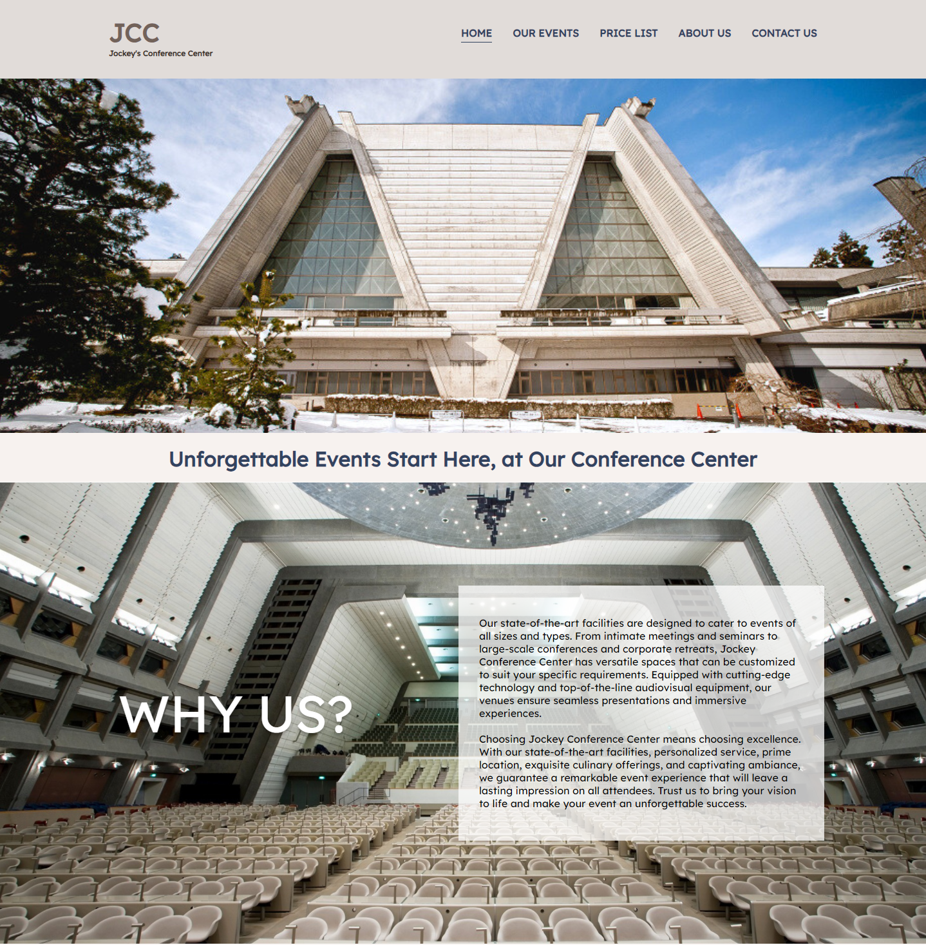

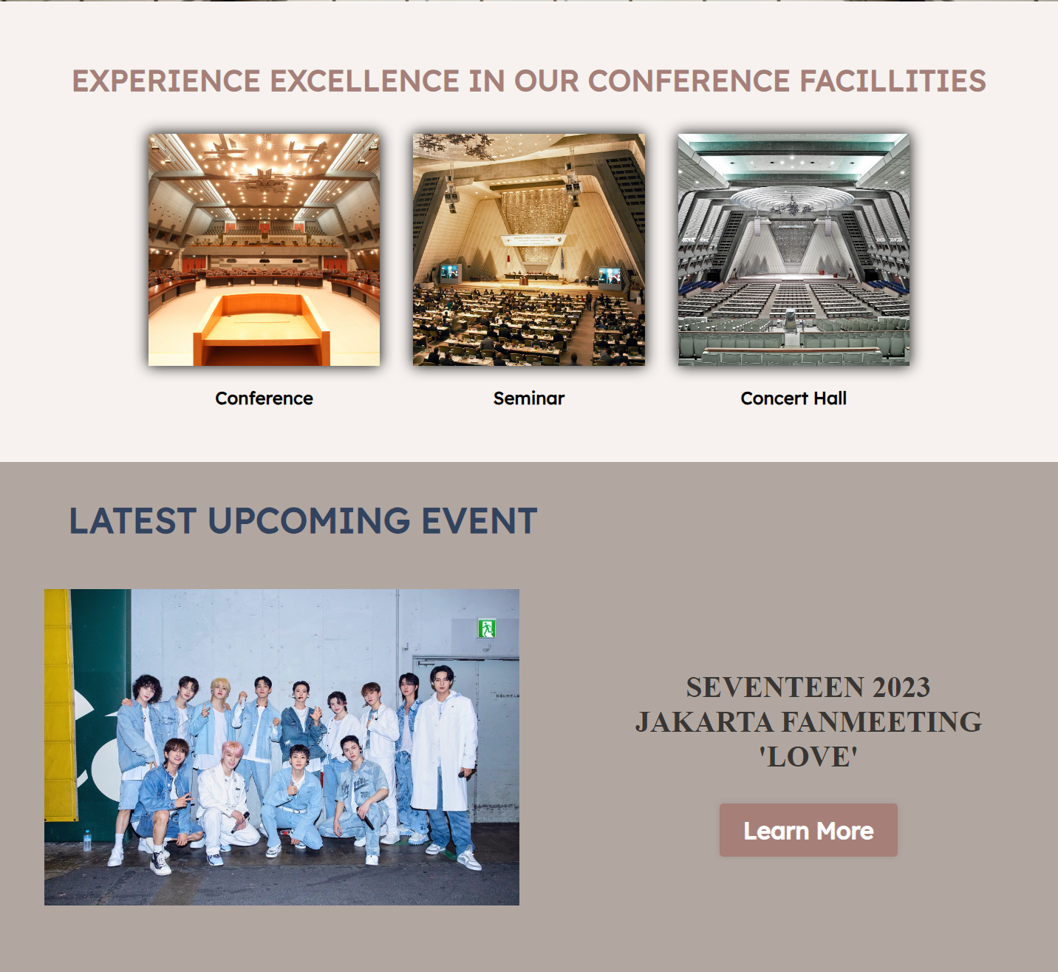  Learn More Button that has an effect when hovered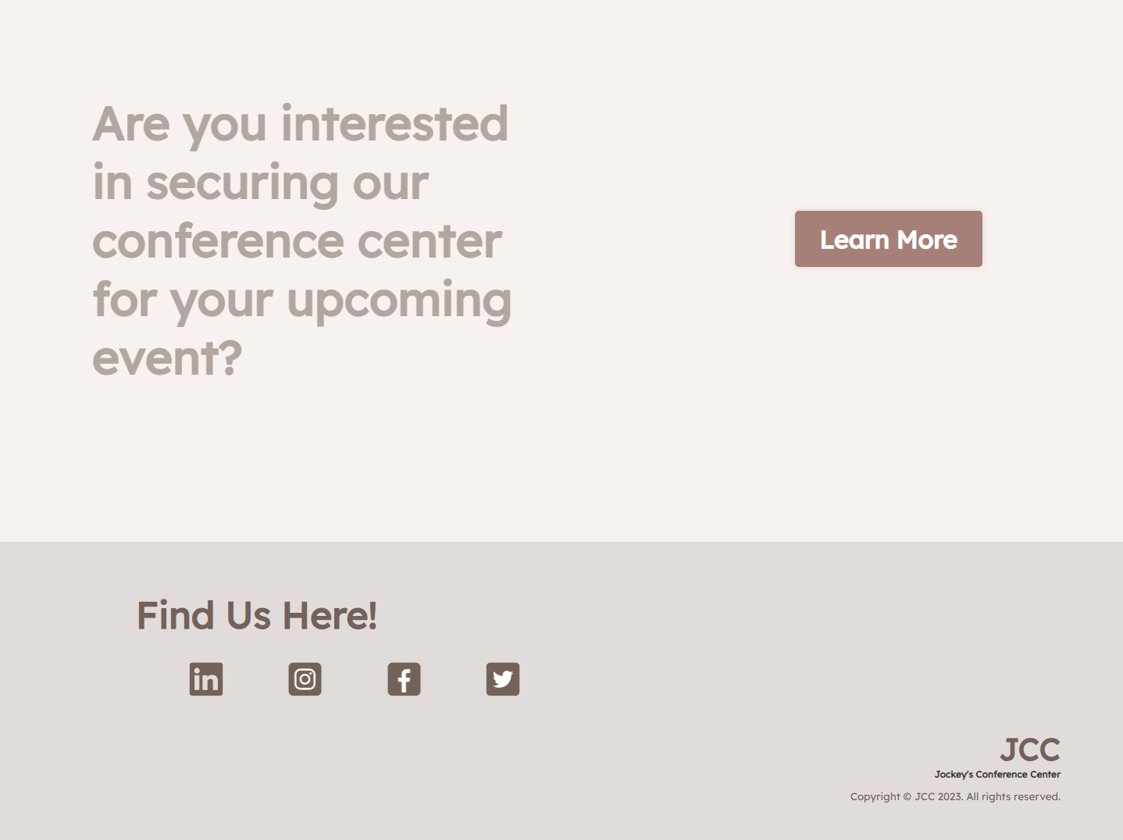

**Events Page**

* Contains list of events that are held by JCC including its events name, picture, description, time, and date.

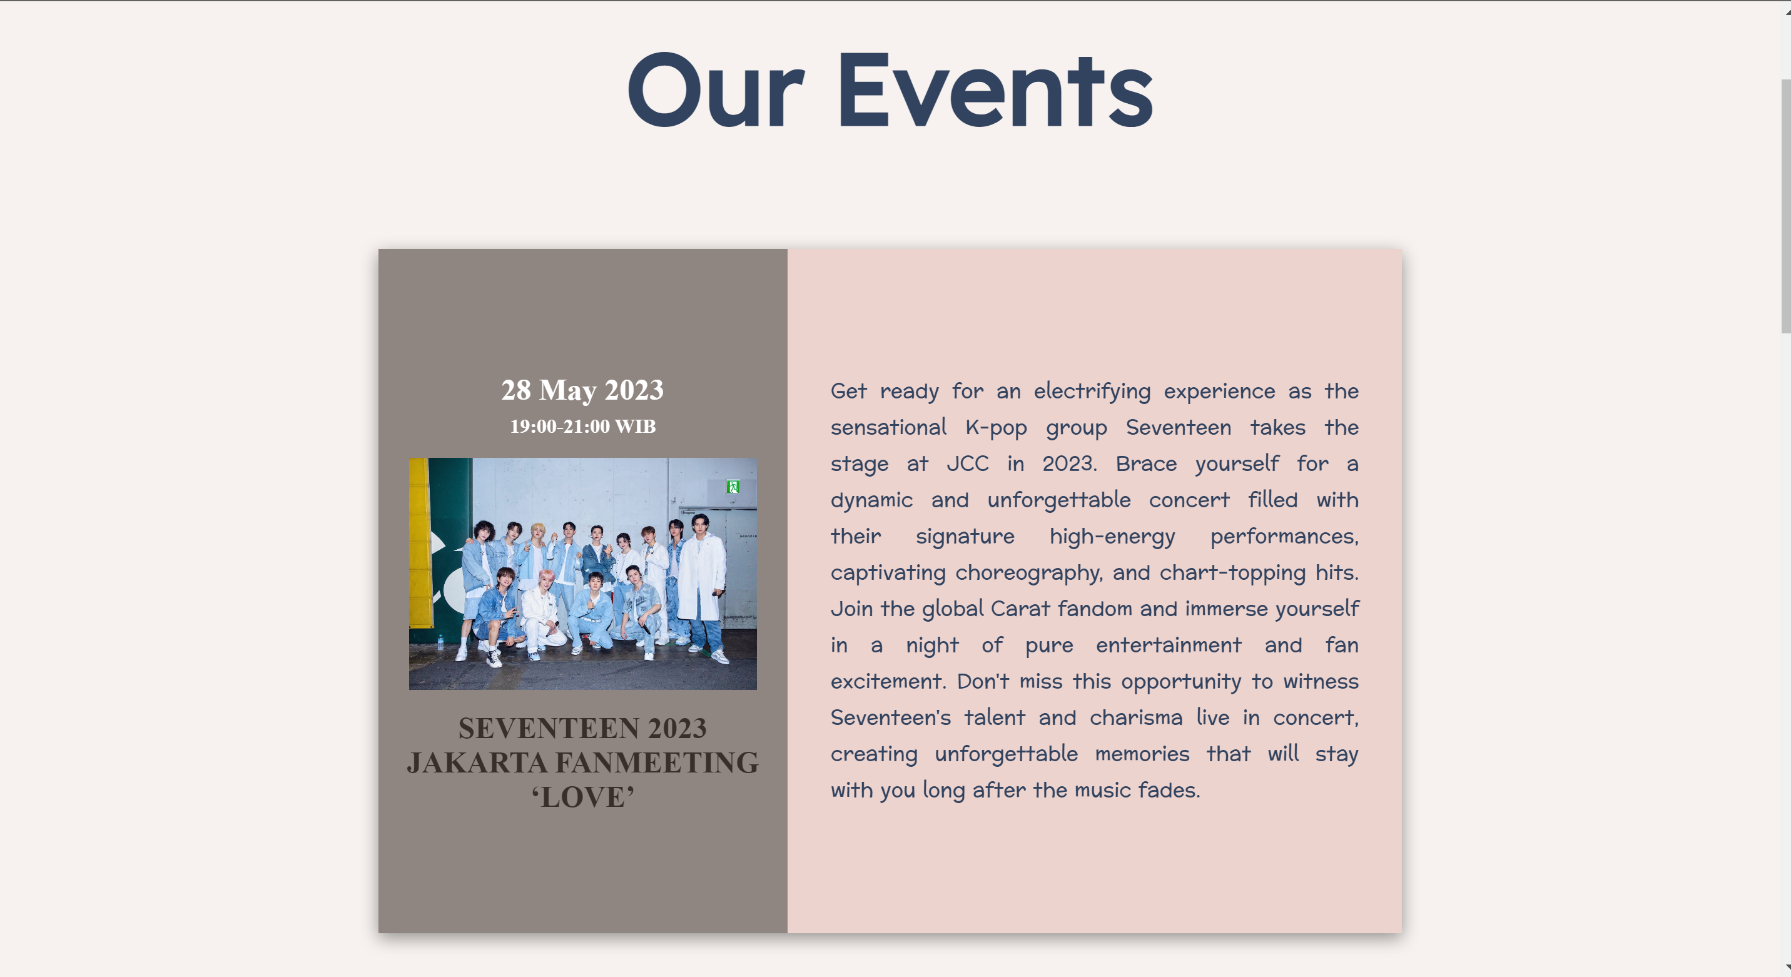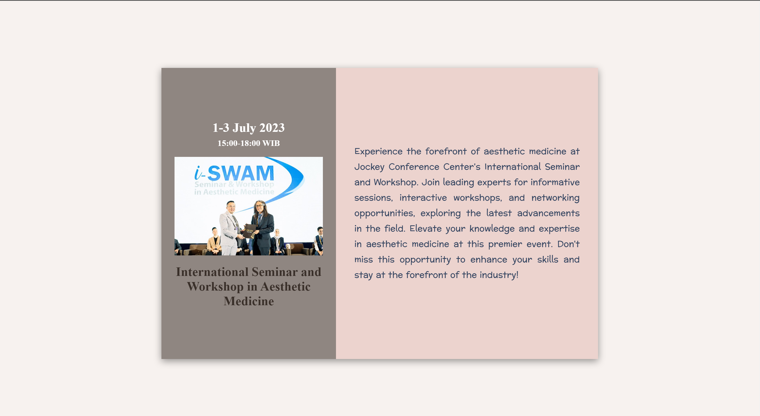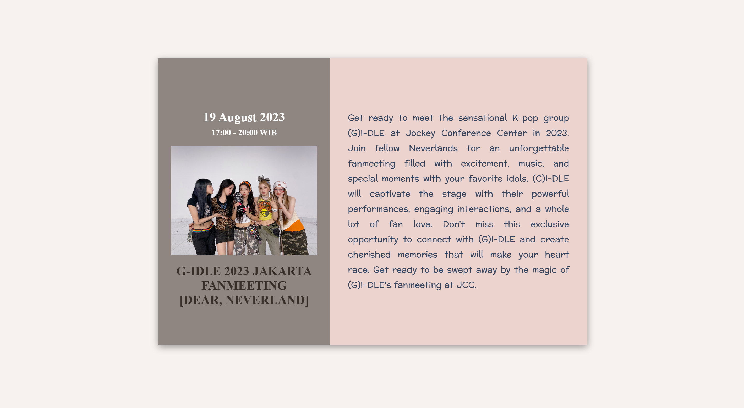

**Price list Page**

* Contains the packages that JCC has to offer including the name of the packages with its starting price and description.

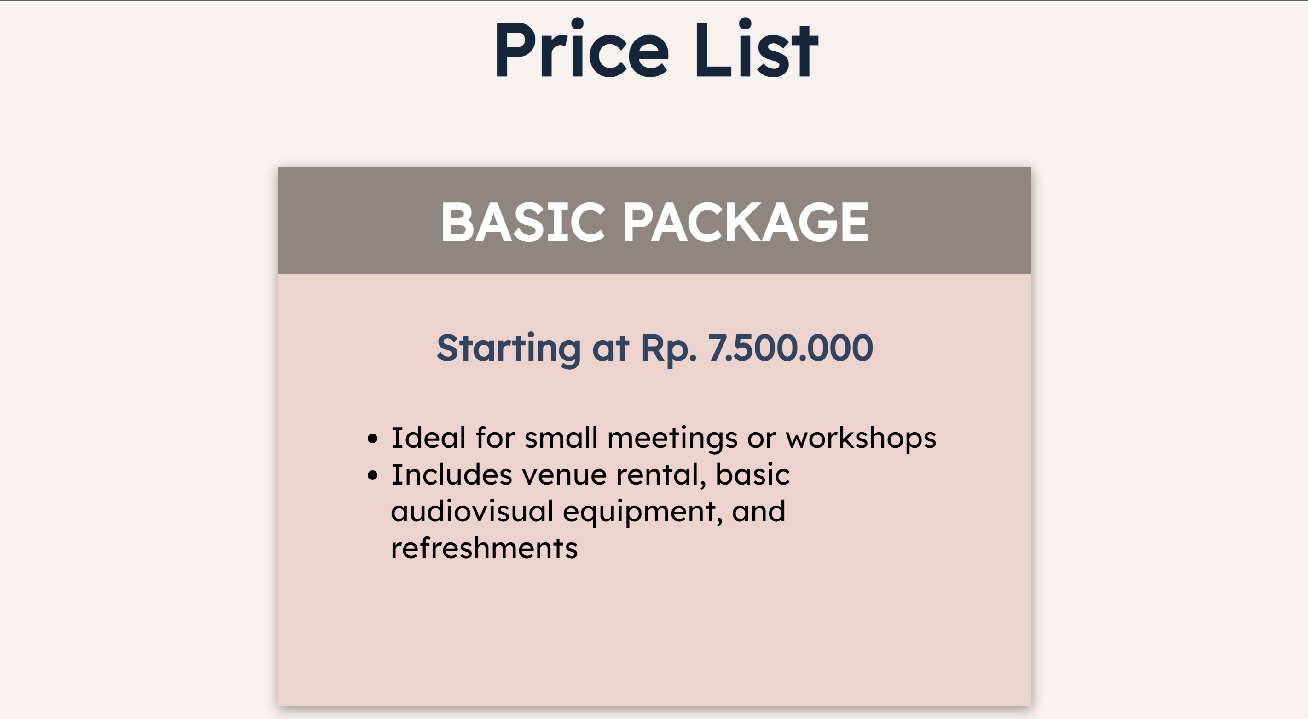

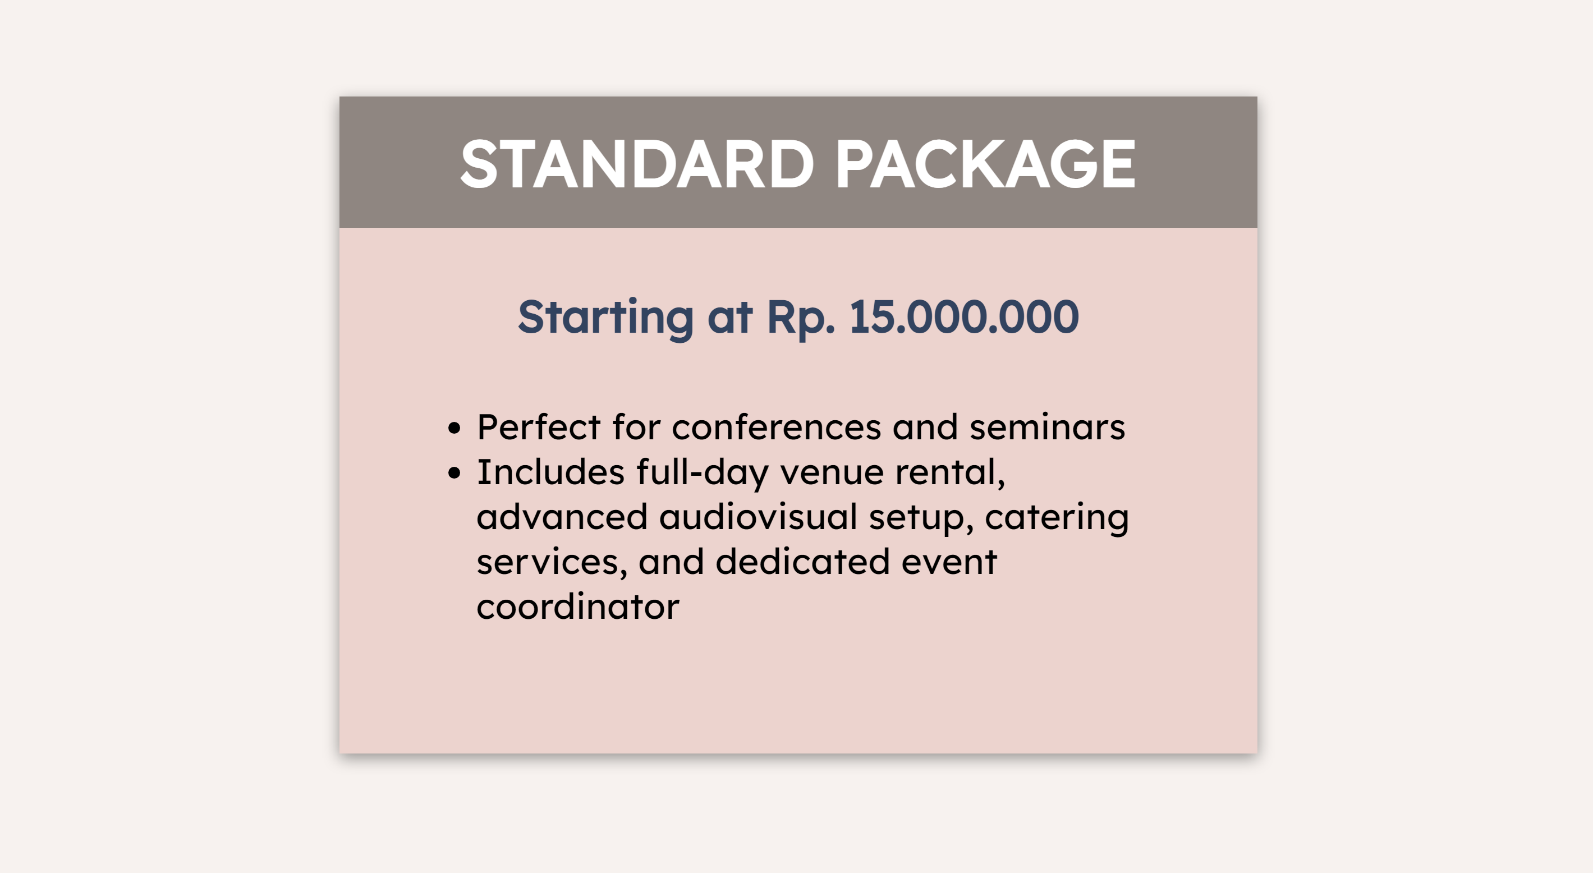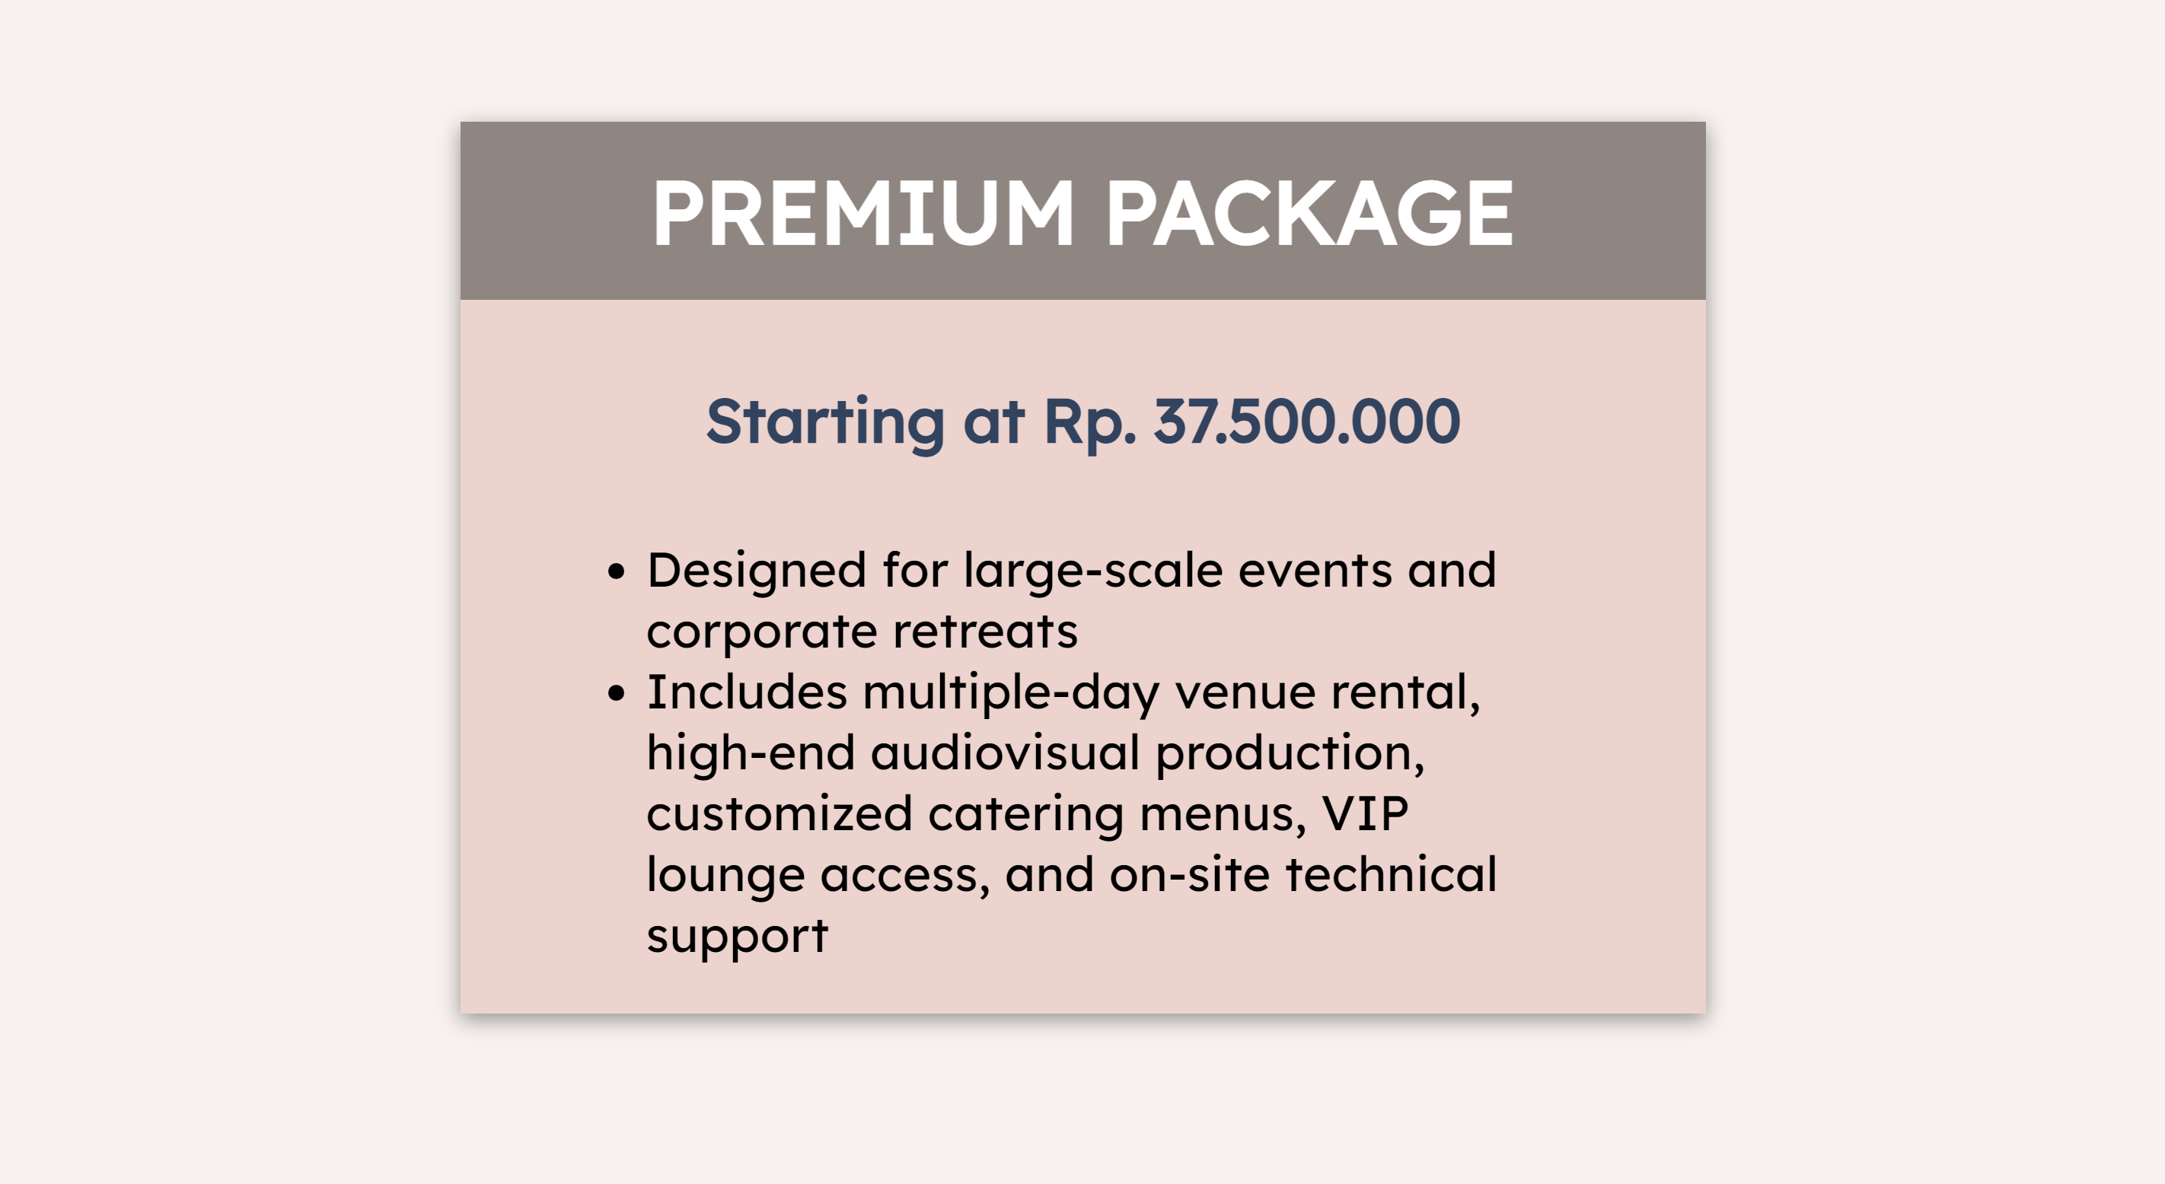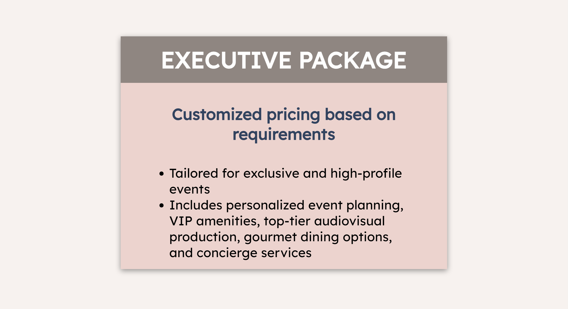

**About Us Page**

* Contains information about JCC’s history and the certification that JCC has received.

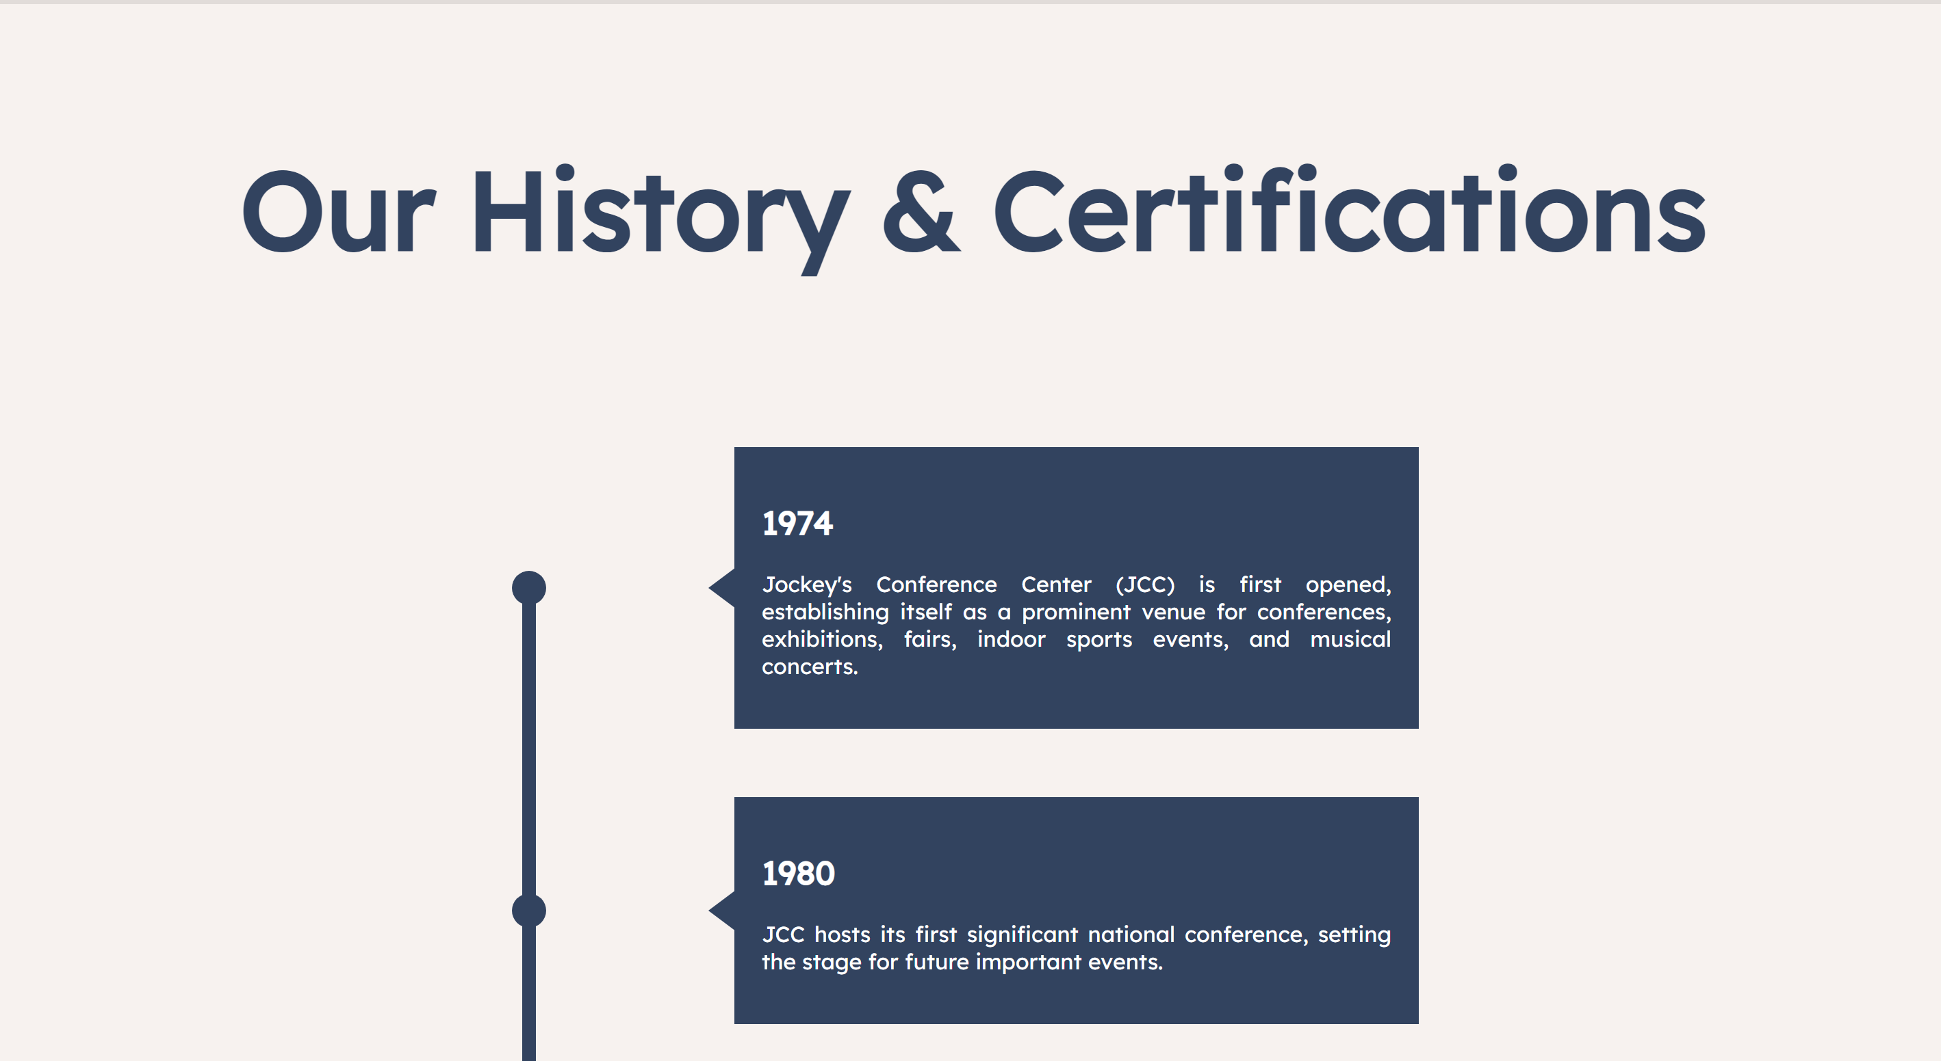

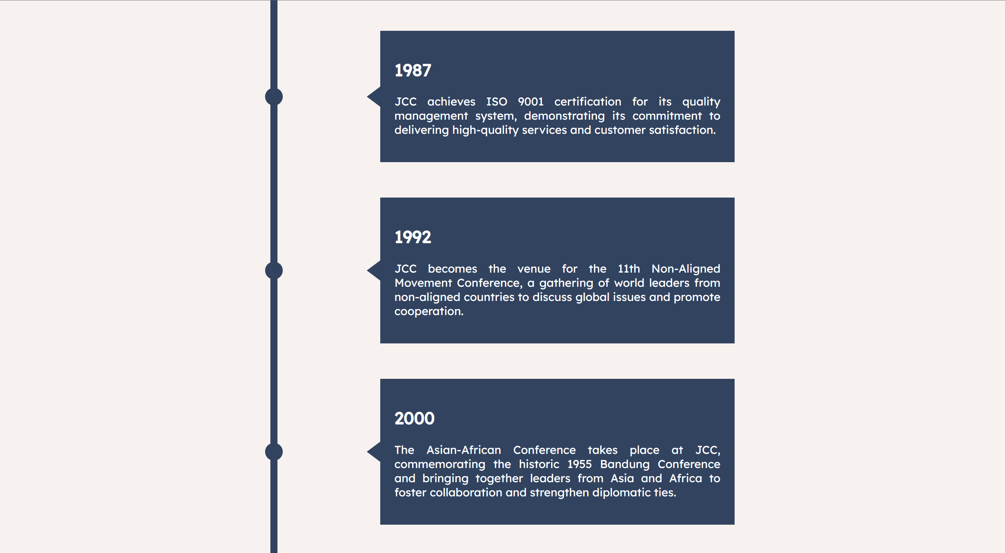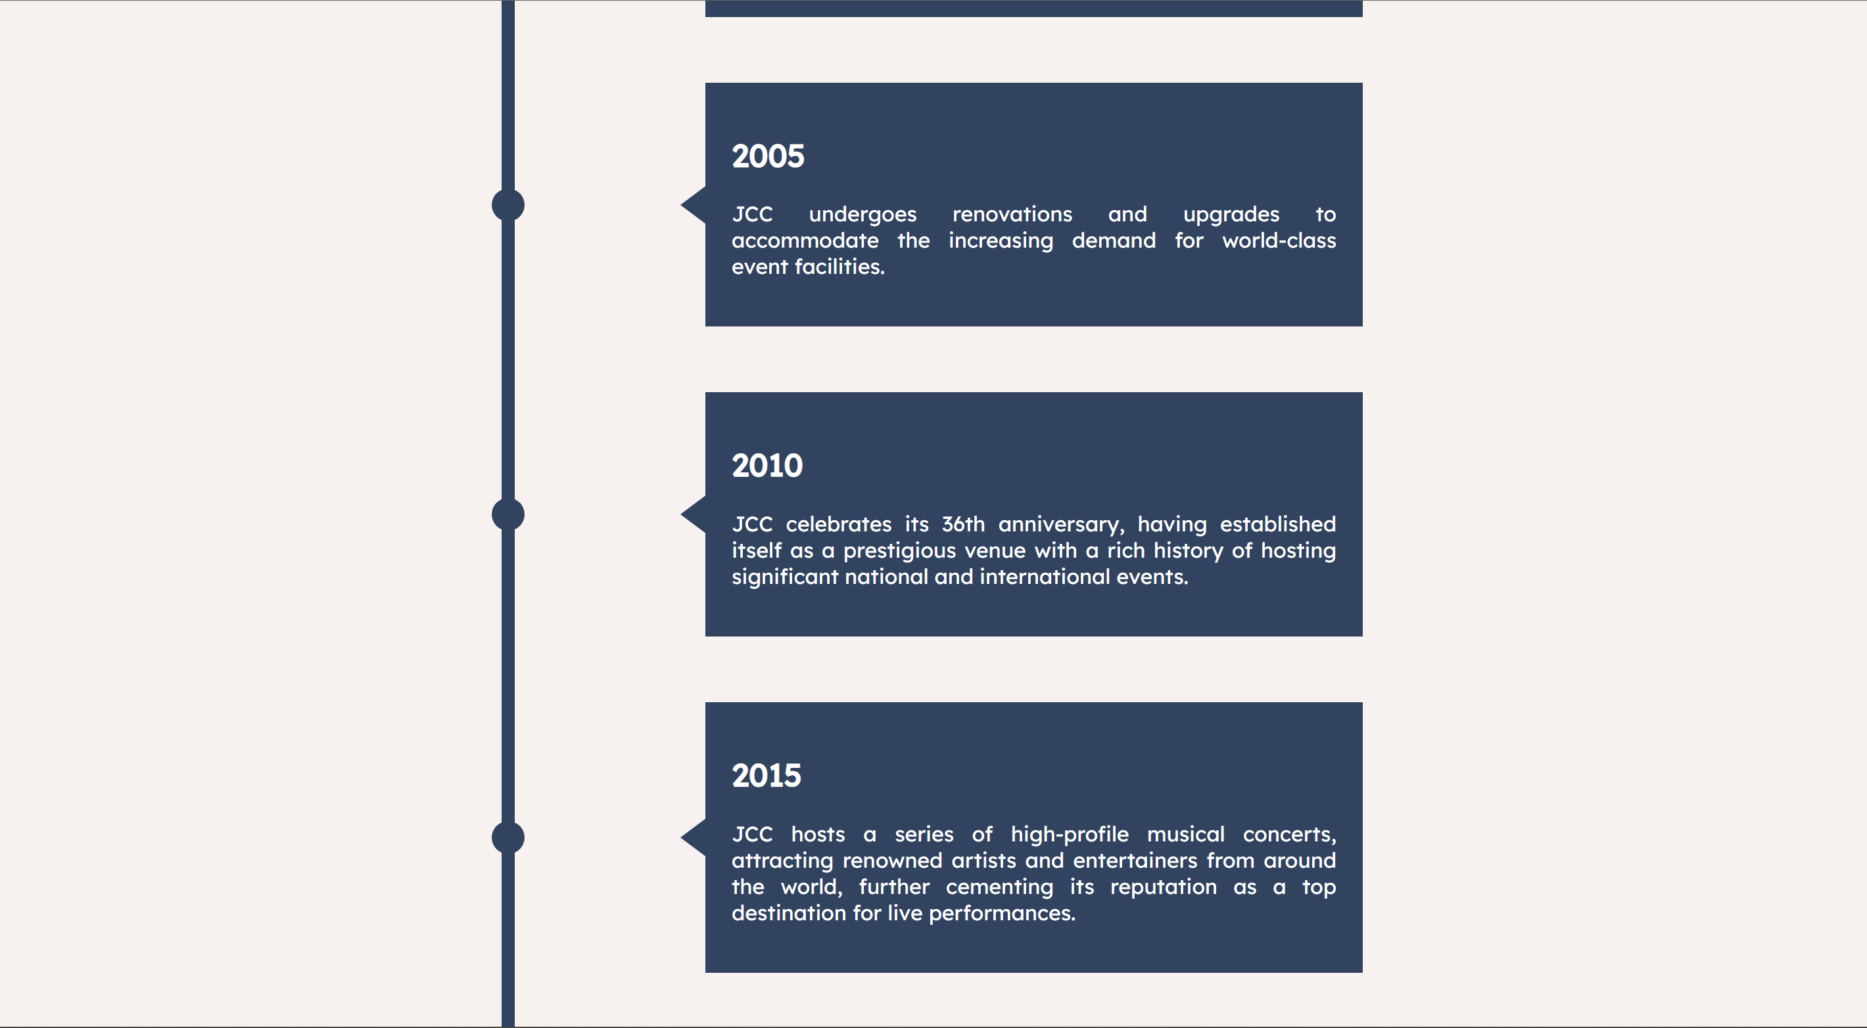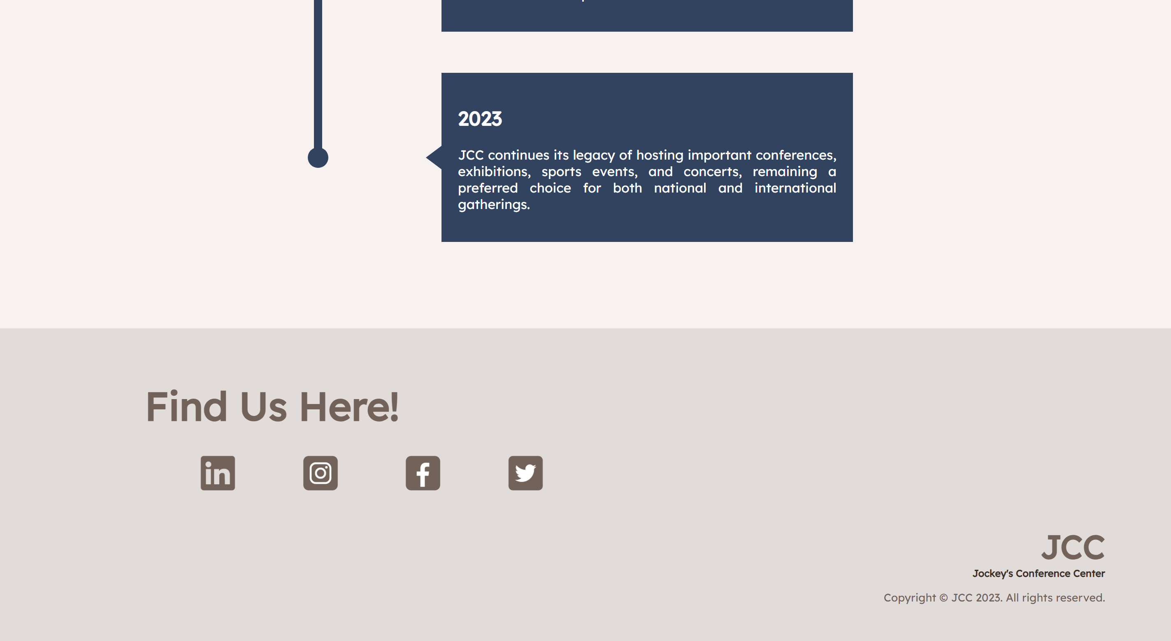

**Contact Us Page**

* Contains contact form for customers where users need to submit their personal information, such as name, email, phone number, message, and preferred contact method (phone and/or email).
* 5 kinds of form components:
  + Text input field for Full Name, Email, Phone Number
  + Select boxes to provide a dropdown menu for Subject
  + Radio buttons for “I’m not a Robot” validation
  + Checkboxes for preferred contact method to allow user to select one or more options
  + Text areas to provide larger input field with multiple lines of text

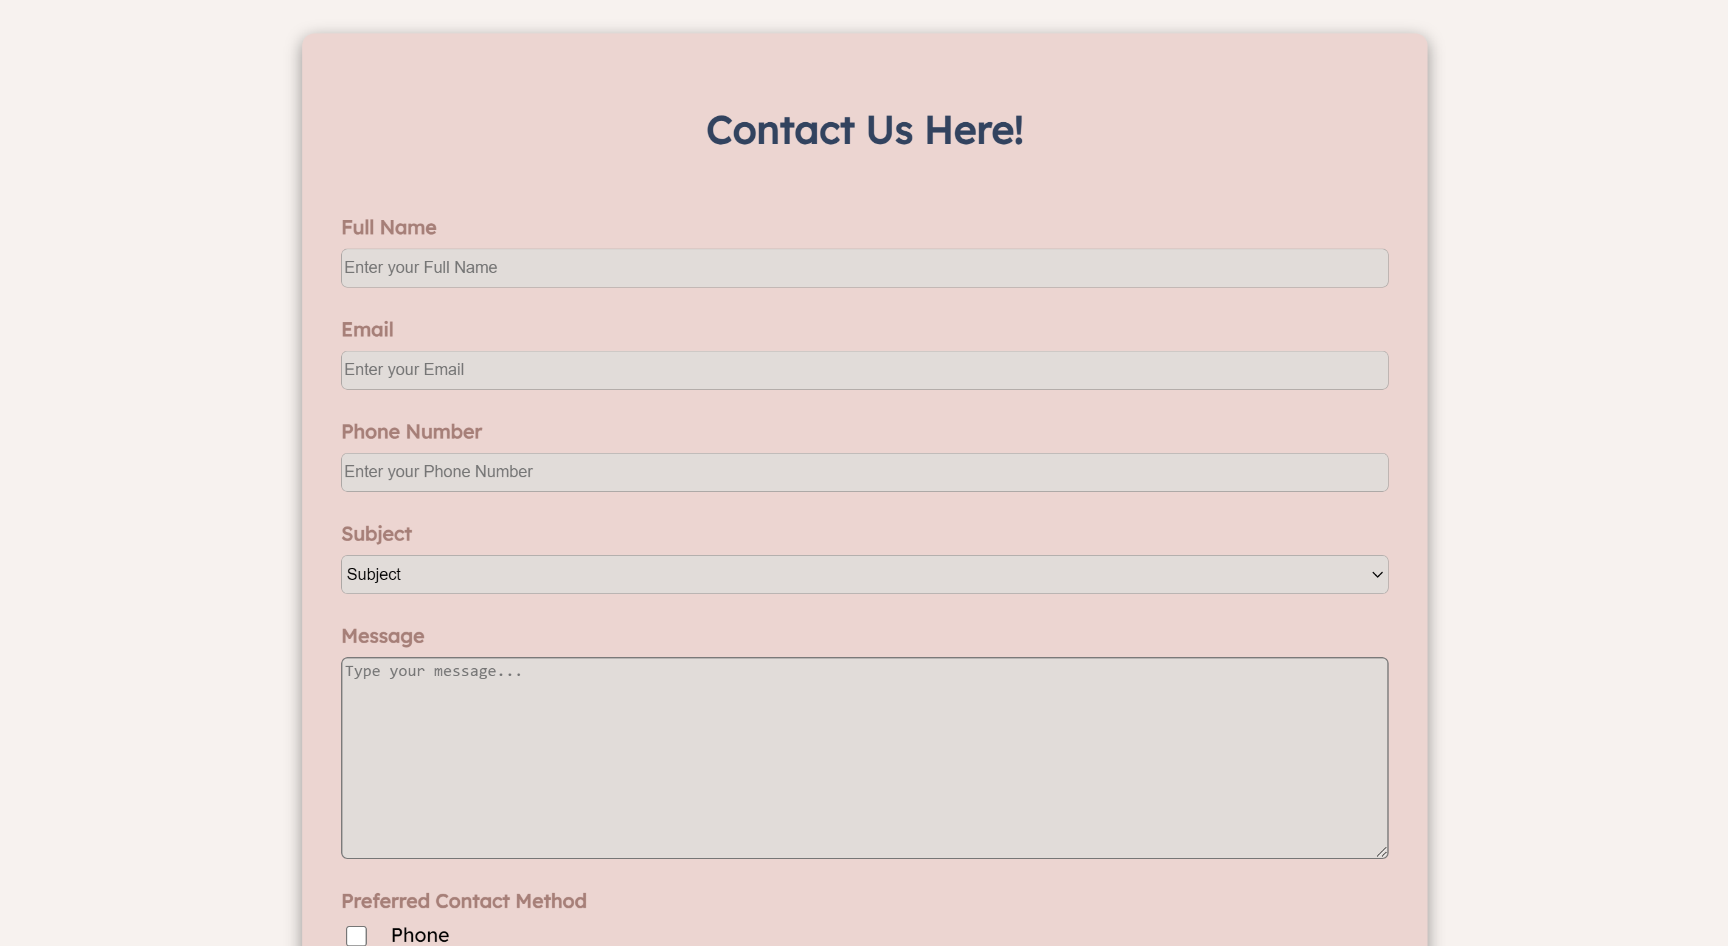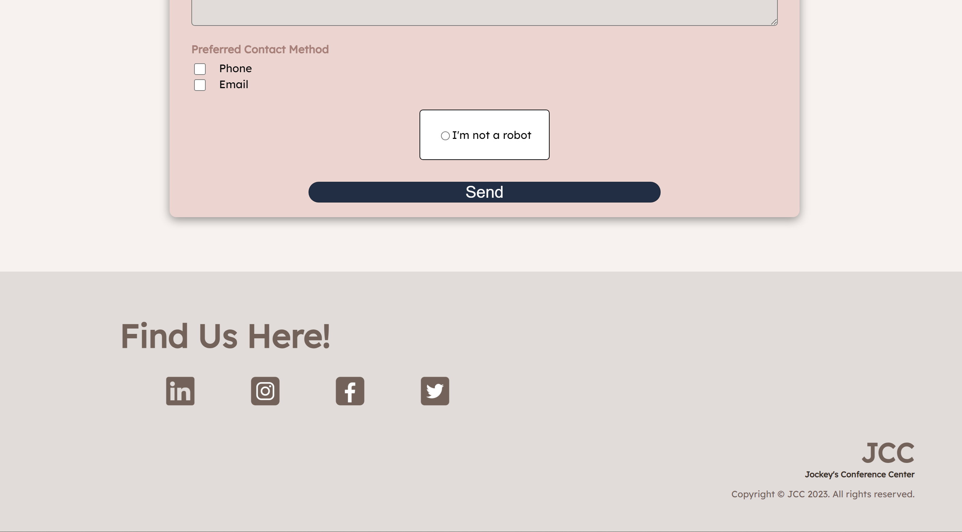

**REFERENCE:**

**ASSETS LINKS:**

Home: <https://www.architravel.com/architravel_wp/wp-content/uploads/2019/08/Kyoto_International_Conference_Center_2.jpg>

Home_2: <https://ttgmice.2017.ttgasia.com/wp-content/uploads/sites/3/2020/05/Kyoto-International-Conference-Center-main-hall.jpg>

Concert: <http://www.iarch.cn/oss.php?local=data%2Fattachment%2Fforum%2F201801%2F02%2F165015ea5ovavz3mac53z5.jpg&file=post_content>

Conference: <https://www.icckyoto.or.jp/wp-content/uploads/2016/12/1_RoomA-from-Stage.jpg>

Seminar: <https://www.unisa.ac.za/static/corporate_web/Content/UHM/timeline/images/1997%20Facing%20global%20climate%20change.jpg?cw_newUrl=/static/corporate_web/Content/UHM/timeline/images/1997%20Facing%20global%20climate%20change.jpg>

Seventeen: <https://images.app.goo.gl/gJQzt8fh91oqyYr57>

Iswam: <https://www.bing.com/images/blob?bcid=Syu3i5TfU7YFr-L6SxFfNPGkqzd......0o>

G-idle: <https://twitter.com/G_I_DLE/status/1661695191735234560?s=20>

**WEBSITE REFERENCE:**

<https://ice-indonesia.com/en>

<https://seattleconventioncenter.com/>

**YOUTUBE LEARNING REFERENCES:**

<https://www.youtube.com/watch?v=srvUrASNj0s&t=9682s>

<https://youtu.be/Pcf4F5xa1xs>

<https://www.youtube.com/watch?v=t5AE66WgQD0&list=PLadwZItl_vQn8TQ8OdEnuwkWpIhVEhGE-&index=1&t=221s>